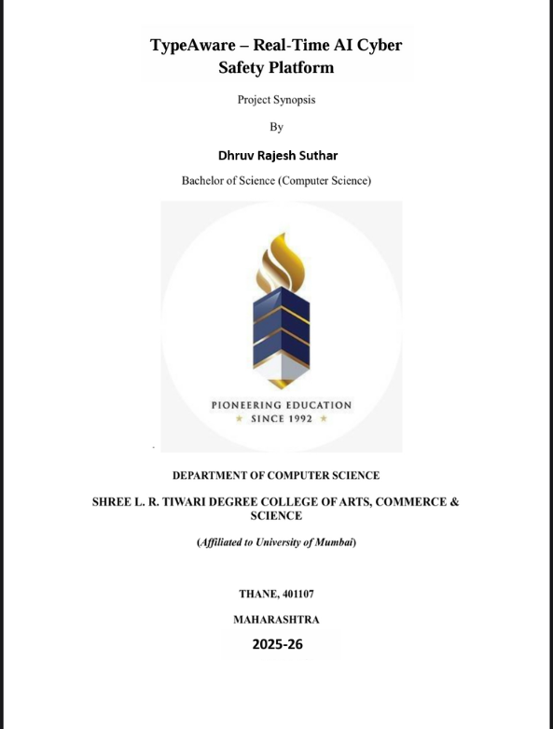

1. Introduction :
With increasing reliance on digital platforms for communication among students, cyberbullying has emerged as a serious concern in schools. Traditional moderation tools detect abusive content only after it is posted. Worse, many students now use disguised formats—like “id!ot”, “s t u p i d”, or “1d10t”—to bypass filters. This project proposes an intelligent AI-based web application that not only detects cyberbullying in real time but also understands obfuscated or intentionally altered offensive language patterns. The system intervenes instantly, offers suggestions, tracks user behavior, and supports school administrators in maintaining a safer digital environment.
2. Project Category:
- Category: Web Application
- Hardware Components: Laptop, Mobile
- Software Components: Visual studio code, GitHub, Postman
- Programming Languages: Python, JavaScript (React)
3. Objectives of the Project:
- To detect and prevent cyberbullying in real-time through typed message analysis.
- To identify disguised harmful language using intelligent pattern recognition.
- To provide instant alerts, rephrasing suggestions, and block repeated offenders.
- To support administrators in monitoring and managing student digital behavior.
- To educate users on respectful communication and digital wellness.
4. System Requirements:
1) Hardware:
- Operating System: Windows 9 or later
- RAM: Minimum 4 GB
- Hard Disk: 1 GB
- Processor: Intel i3 or higher
2) Software:
  - React js (frontend), tailwind CSS
  - Browser (Chrome/Edge
  - Node.js & Python 3.x
  - MongoDB
5. Scope of the Project:
  - Real-time detection of typed abusive content using on-device NLP
  - Obfuscation-aware detection using fuzzy matching and regex
  - Warnings and positive rephrasing suggestions
  - Messages can also be reported by users; repeated reports lead to user blocking
  - Admin dashboard for flagged messages and behavior metrics
  - Temporary blocking for repeat offenses
  - Anonymous behavior tracking for safety and compliance

6. Result:
The system successfully prevents offensive or disguised messages from being posted by detecting intent before submission. It creates a safe digital space for students, encourages self-correction, and empowers school authorities with a dashboard to take timely actions. With built-in awareness features and privacy-first design, the platform serves as both a preventive and educational tool against cyberbullying.

